**1) Workshop on CFD -7th,8th October**

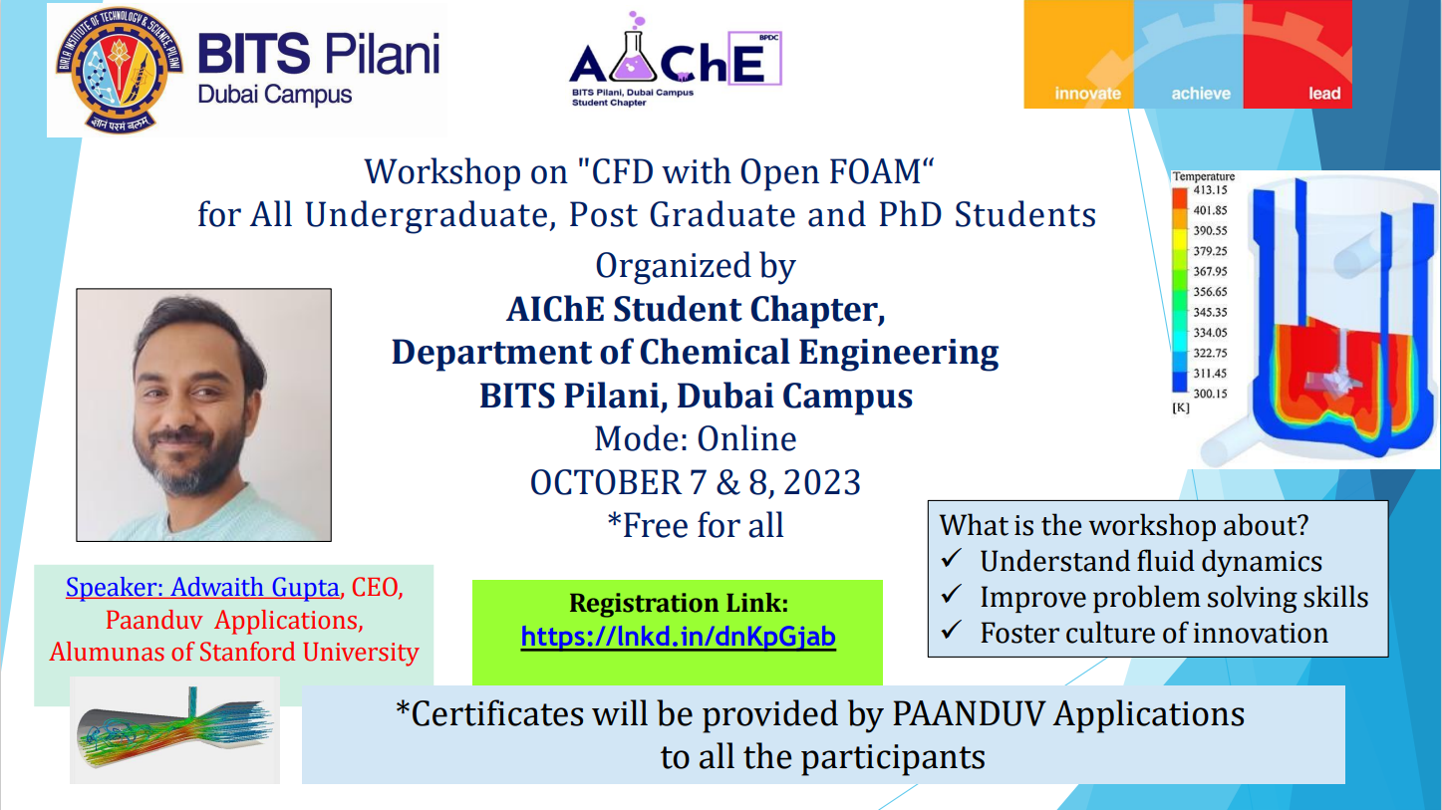

On the 7th of October 2023, AIChE hosted the Computational Fluid Dynamics (CFD) workshop using the Open Foam Software. The session was conducted by Mr. Adwaith Gupta, CEO of Paanduv Applications. It was open to all undergraduates, post graduate and PhD students. The workshop succeeded in sparking intrigue in the field of fluid dynamics while enhancing the problem solving skills of the attendees and fostering the vigor for innovation.

**2- BTF AKSI EXPO- 15th October**

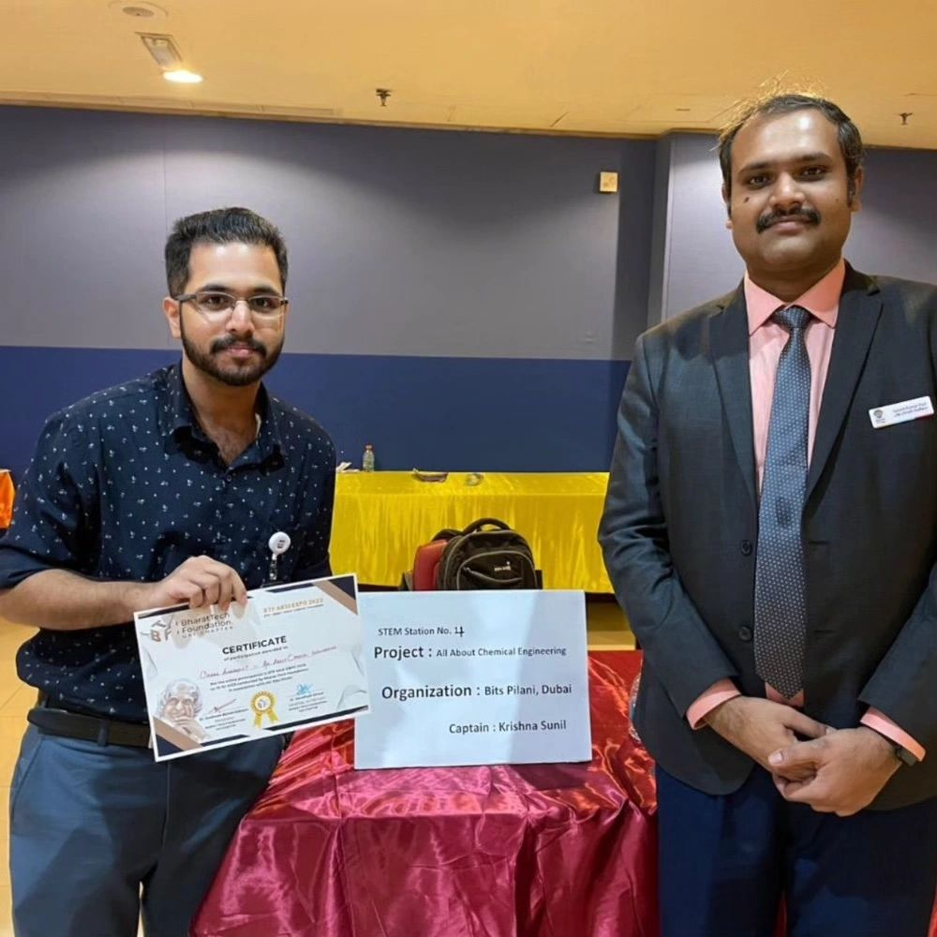 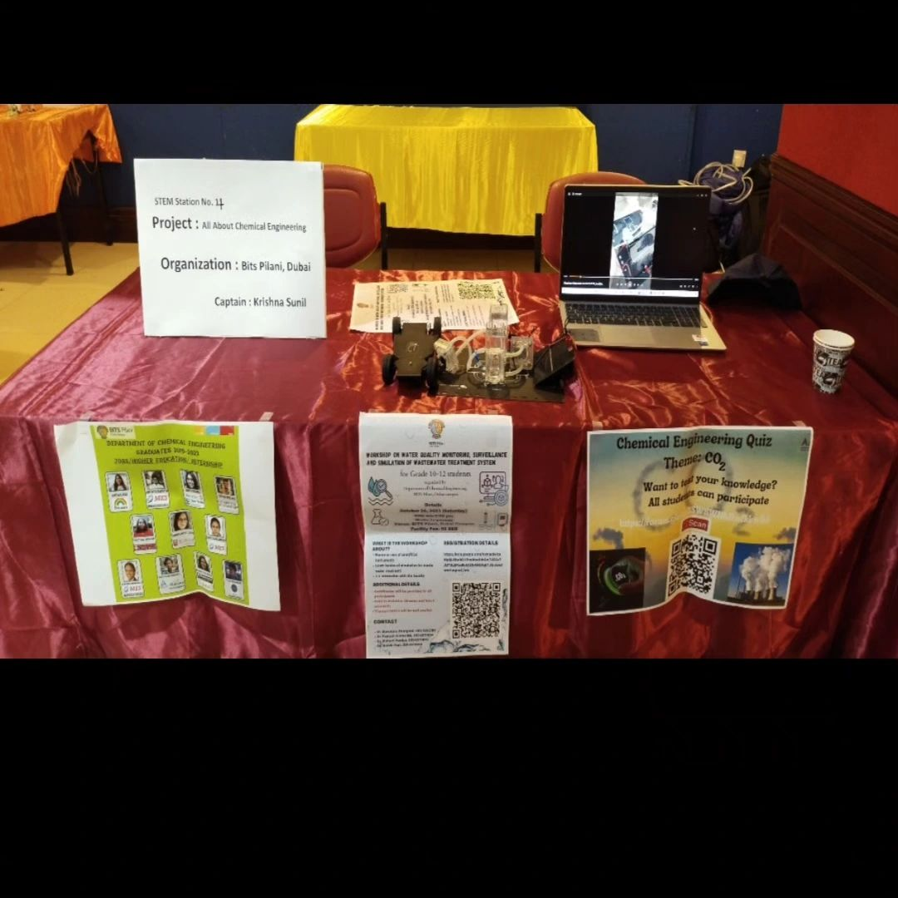

We are delighted to announce that the Chemical Engineering department of Birla Institute Of Technology and Science, Pilani Dubai, has secured the Overall Achievement prize at the BTF AKSI EXPO 2023.

3rd Year Chemical Engineering student Krishna Sunil has bagged this achievement for his demonstration of the Chem-E-car concept based on hydrogen fuel.

**3)EXCEL WORKSHOP- 23rd November**

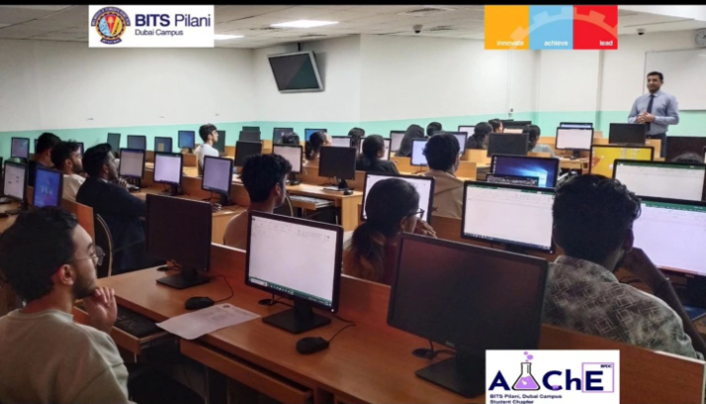

Working on excel can be tiresome. We have all been there at some point. And so, the Chemical Engineering Department at [Birla Institute Of Technology and Science, Pilani Dubai](https://www.linkedin.com/company/bitspilanidubai/) decided to conduct an Advanced Excel Workshop for all those who wished to 'excel' at 'Excel'.

Our very own professor, Dr. [Nishant Pandya](https://www.linkedin.com/in/nishant-pandya8/) led the workshop, providing insight into the fundamentals of excel and data handling. The workshop was attended by students and professors alike, who will receive certificates for their participation.

**4) Meetup with the AiChEs- 17th January, 2nd Febraury, 16th February.**

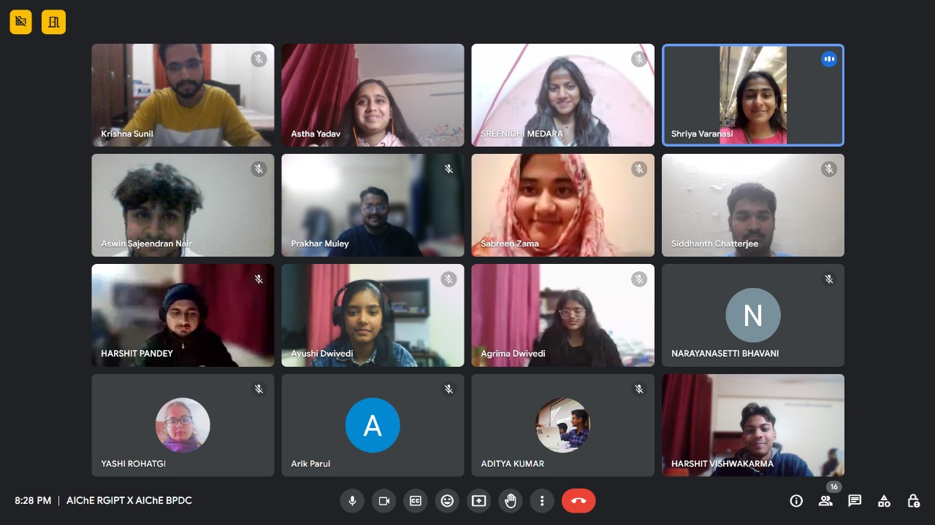 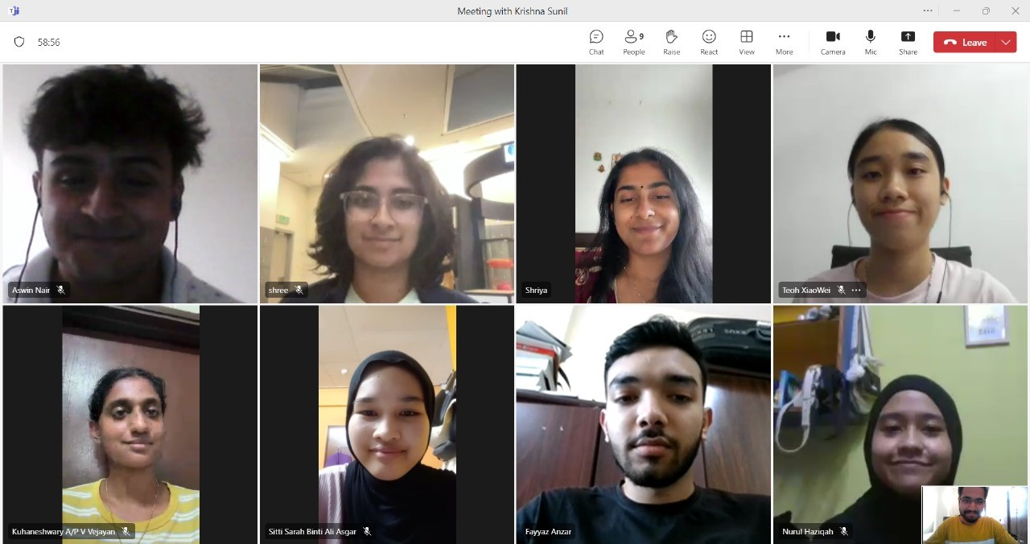

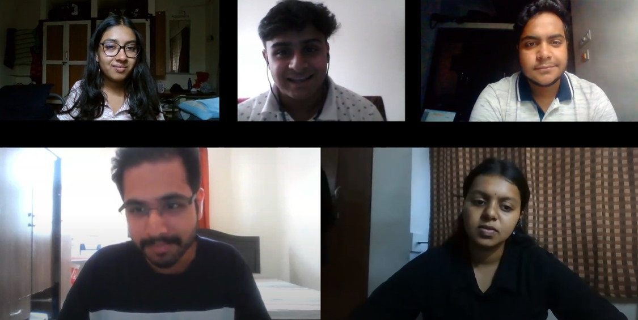

The months of January and February saw AIChE BPDC expand its network through meetups with universities around the globe. The club kick-started its endeavour through a gathering with AIChE-RGPIT from Uttar Pradesh. This was soon followed by participation in the podcast, Chemically Doped, hosted by AIChE-VIT. We decided to venture even further when we joined hands with AIChE UTP from Malaysia for a collaboration in the works.