ABSTRACT TITLE
First Author, Second Author
Same Affiliation, Postal Address, E-mail addresses
Third Author
Different Affiliation, Postal Address, E-mail address

ABSTRACT
This is a template for the extended abstract, which is the only file required for this Conference. Extended abstracts are submitted through the Conference website, reviewed and, once accepted can be uploaded in the final version (revised if required by the reviewers). From here the terms “extended abstract” or “abstract” will be used indistinctively. Please follow the instructions below.
Key Words: Heat Transfer, Finite Elements, Natural Convection.
1. INTRODUCTION
Potential authors are invited to submit an abstract with this format before 31, 2024. The abstract can be uploaded via the Conference website (www. ).
2. MAIN BODY
Abstracts should outline the main features, results and conclusions as well as the general significance of the contribution. Relevant references, figures, and tables are welcome. However, please note that extended abstracts
- can only be accepted as .pdf files not larger than 3MB;
- must not exceed four pages;
- must be written in English.
Abstracts will be reviewed and acceptance will be communicated to the authors by November 15, 2024. Authors will then have the chance to upload the revised/final version of their abstract.
3. RESULTS
The main results should be presented in a specific section of the extended abstract. Relevant references, figures, and tables are welcome. An example of the format to be used for figures in extended abstracts is given in Figure 1. Authors who wish to include tables in their extended abstract should use the format provided in Table 1.

Title | List 1 | List 2 | List 3 | List 4 | List 5 | List 6
10⁴ | C22 | C23 | C21 | C22 | C21 | C22
10⁴ | C32 | C33 | C31 | C32 | C31 | C32
10⁴ | C42 | C43 | C41 | C42 | C41 | C42
10⁴ | C52 | C53 | C51 | C52 | C51 | C52
10⁴ | C12 | C13 | C11 | C12 | C11 | C12
Table 1. Example of the format to be used for Tables

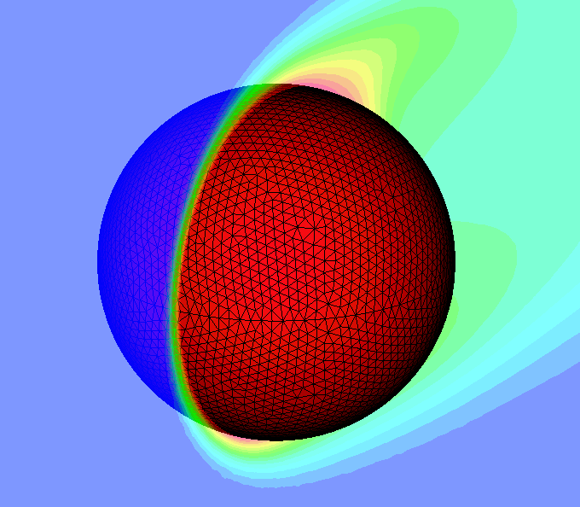
Figure 1. Example of the format to be used for Figures
4. CONCLUSIONS
Please note that the final acceptance of papers for presentation is conditional on one of the authors registering before the deadline. Multiple presentations are only allowed if the papers are of very high quality. One presentation per delegate is allowed.
REFERENCES
[1] N. Massarotti, F. Arpino, R.W. Lewis, and P. Nithiarasu, Fully explicit and semi-implicit CBS procedures for incompressible flows, International Journal for Numerical Methods in Engineering, 66, 1618-40, 2006.
[2] O.C. Zienkiewicz and R.C. Taylor, The Finite Element Method, 4th Edition, Vol. I, McGraw Hill, 1989, Vol. II, 1991.

