**SOCIETY OF WOMEN ENGINEERS**

**REPORT 2024-25**

**BY**

**DR R SWARNALATHA**



**SOCIETY OF WOMEN ENGINEERS**

**EXECUTIVE BOARD 2024-25**

| **Core Committee** | | |
| --- | --- | --- |
| President | Shifa Yashfeen Mohmed | 2021A7PS0277U |
| Vice President | Shyma Sulthana | 2021A9PS0293U |
| General Secretary | Hibah Fathima | 2022A7PS0317U |
| Treasurer | Kritika Rathi | 2022A4PS0300U |
| **Sub-Committee** | | |
| Executive of Events | Saanchi Kasar | 2021A9PS0329U |
| Executive of Decor | Meghavardini Jothikannan | 2021A9PS0044U |
| Executive of Marketing | Smruti Koul | 2022A7PS0148U |
| Executive of Content Design | Megha Aby Alex | 2021A9TS0137U |
| **Committee Members** | | |
| Events Coordinator | Anoushka Martin | 2022A9PS0129U |
| Events Coordinator | Ilfa Shaheed Valiavallappil | 2021A7PS0048U |
| Events Coordinator | Sheza Shuhaib | 2022A9PS0090U |
| Events Coordinator | Shraddha Rajesh | 2022A7PS0214U |
| Events Coordinator | Deeya Gupta | 2022A9PS0209U |
| Events Coordinator | Shivaani Srinivasan | 2022A9PS0197U |
| Decor Coordinator | Akanksha Judith Pinherio | 2023A9PS0044U |
| Decor Coordinator | Alina Josephin Biju | 2022A7PS0309U |
| Decor Coordinator | Briana Joan Mathew | 2023A9PS0017U |
| Marketing Coordinator | Zoya Fowaz | 2022A9PS0269U |
| Marketing Coordinator | Aleakhya Pandeti | 2022A7PS0016U |
| Marketing Coordinator | Prisha Bansal | 2023A7PS0273U |
| Content Design Coordinator | Vania Roy | 2023A3PS0365U |
| Content Design Coordinator | Navya Vijay | 2023A4PS0250U |

**

**SEPTEMBER 2024………………………………………………………………………………Pg 4**

-Fresher’s Day Stall

-Masters Abroad: Insights and Strategies

-Structural Engineering Competition

**OCTOBER 2024………………………………………………………………………………….Pg 6**

-Championing Women: Health, History, and Awareness

**NOVEMBER 2024……………………………………………………………………………….Pg 7**

-PhD Abroad: Insights and Strategies

- SWEet Retreat Picnic

**SEPTEMBER 2024**

1. **Fresher’s Day Stall**

SWE organized a stall for students on 29th August 2024

Students were brought together via fun and interactive activities

Students were acquainted with SWE council members and faculty in charge

On spot registrations were done

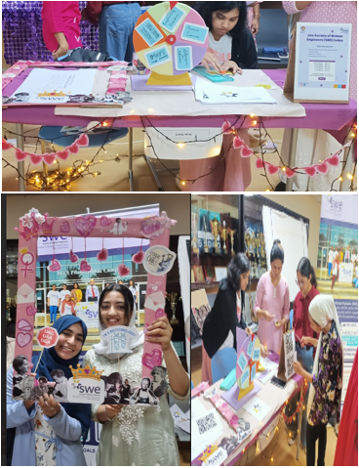

1. **Masters Abroad: Insights and strategies**

SWE hosted a webinar featuring two BPDC Alumni (Gurusshitha Subramanian & Joshita Pentapati) who pursued Bachelor of Engineering in Biotechnology

Hosted on 22nd September, 2024 via Google Meet

The alumni shared their Masters experience abroad and spoke about the application process for the same.

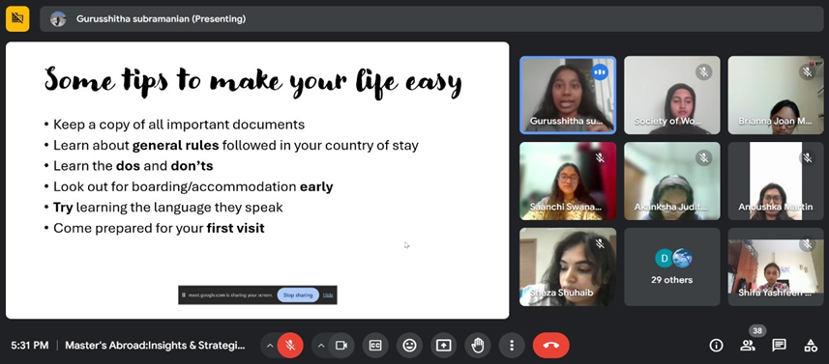

1. **Structural Engineering Competition**

Organized on 11th September, 2024 in Room G34

In the first challenge, the teams were tested on their creativity by constructing a bridge out of ice cream sticks, which was then judged by its ability to withstand heavy weights.

The second round revved up the fun as the various teams built race cars using balloons, plastic bottles and many other materials, all competing to see which car could run the farthest.

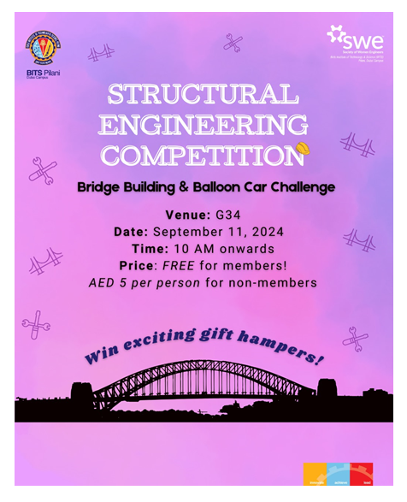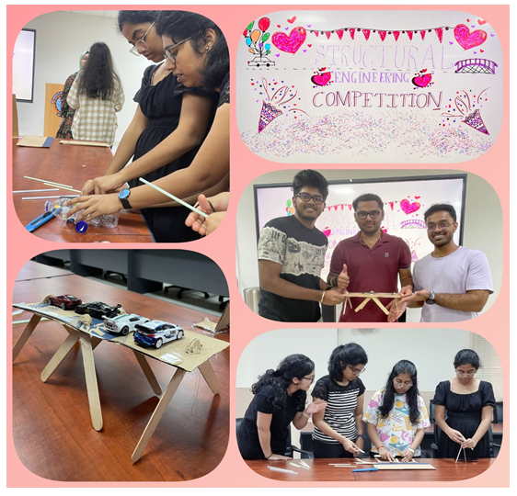

**OCTOBER 2024**

1. **Championing Women: Health, History, and Awareness**

Organized on October 10th, 2024

Aimed at promoting women's health and history, while raising awareness about causes like breast cancer and mental health

A symbolic activity called *"Painting Hearts"* encouraged participants to creatively paint hearts in support of breast cancer survivors

The event also featured a *"Well-Being Check-In,"* where individuals used colors to express moods like joy, calm, and sadness, fostering mental wellness

Free snacks were also provided to the top 10 winners of every hour

**NOVEMBER 2024**

1. **PhD Abroad: Insights and strategies**

Webinar hosted on November 3rd , 2024 via Google Meet

Featured BPDC alumni and former SWE President, Preethika Thiraviam

She is now a PhD student at University of Chicago, specializing in Molecular Engineering with a focus on Quantum Science

Discussed her life along the course of her study in BITS Pilani Dubai Campus.

Focused on choice of elective and the importance of them in your latter years of the bachelor's programme

1. **SWEet Retreat Picnic**

SWE’s flagship event was held on 20th November 2024 in DIAC Park

Female students were invited to wear floral-coloured clothes and join us in DIAC Park for a day to connect, network and enjoy a day out with fellow women engineer students of all years.

