**Treble Annual Report 2023-24**

Dear members,

We are very pleased to present the annual report of the BITS Pilani Dubai Campus Music Club, Treble. The past academic year has been quite eventful with many of our students participating in various events, many of which were hosted by other clubs.

**Achievements in Events for the Academic Year 2023-2024**

# **IceBreakers - September**

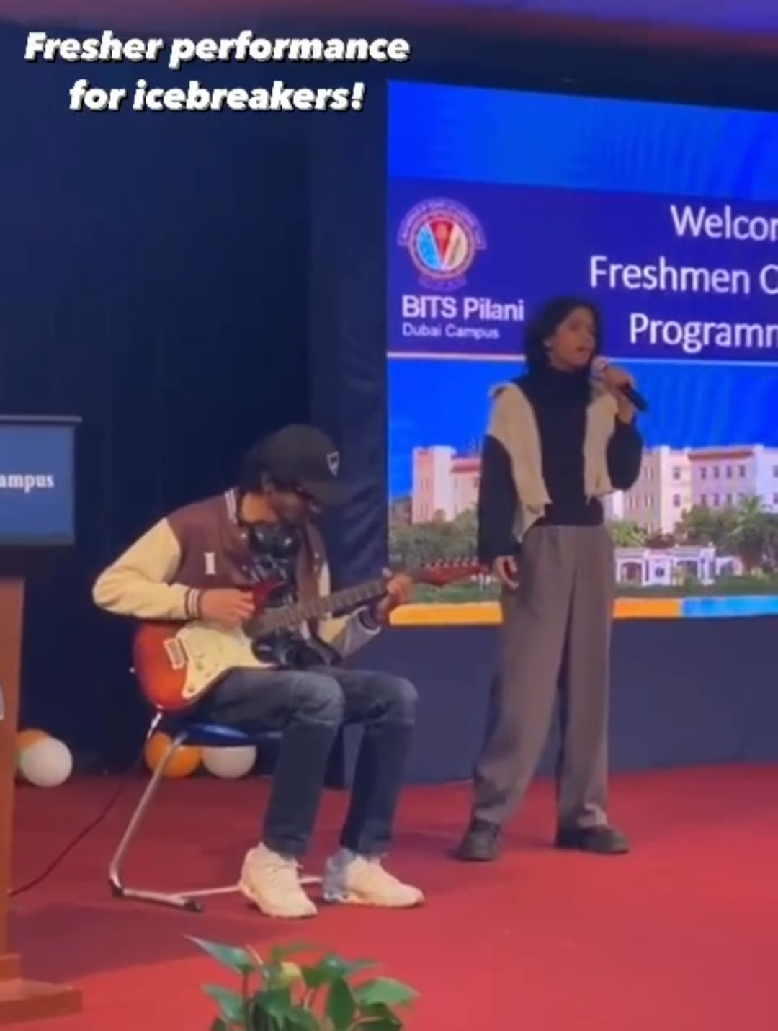 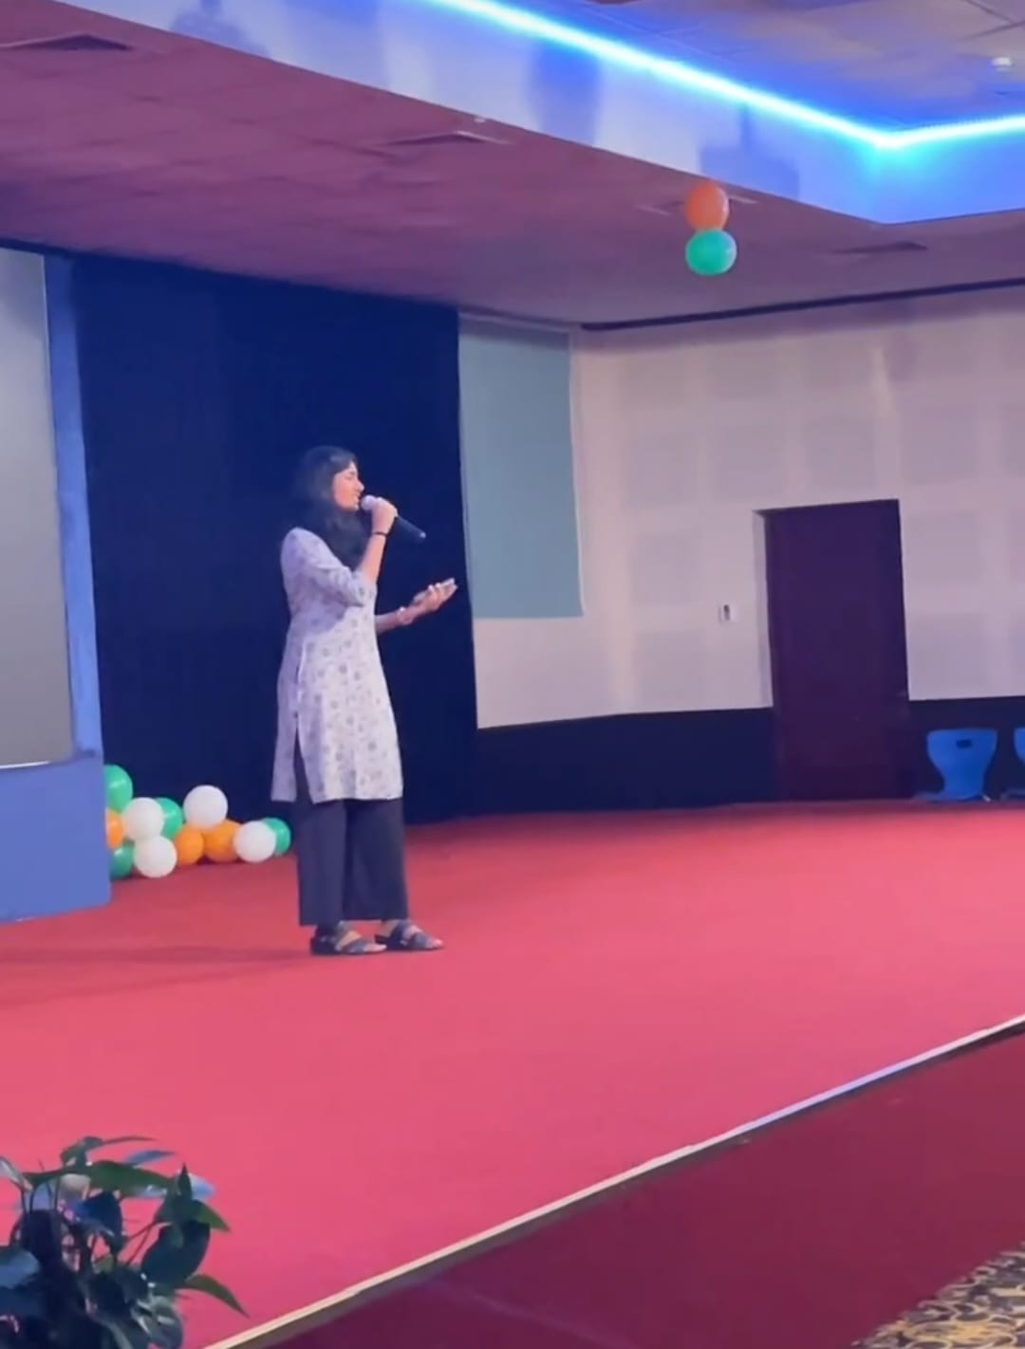

Ishan Menezes and Chinmayi Sayana Megha Jayakumar

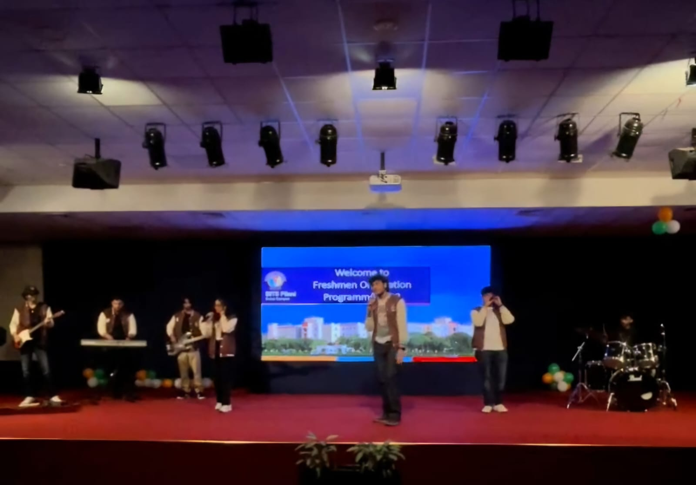

Sinister 6ix (Band) Performance

As part of **IceBreakers**, the event began with an electrifying introductory performance by the official band of BITS Pilani, Dubai Campus. Their dynamic set energized the audience, setting a vibrant tone for the event and exemplifying the musical talent and spirit of the Music Club.

IceBreakers gave us the opportunity to canvas the club to the freshmen just coming in, giving them a taste of the Music Club experience. There were few performances from the freshers, who were eager to display their talents to the college, giving some of them their very first stage. It was a great launch to the year and after the auditions, we got a lot of new members from the fresher batch joining the club. A few of them went all the way to Jashn in their very first year.

# **Gandhi Jayanti - October**

Raghupati Raghav Raja Ram was performed by our members to commemorate the event of Gandhi Jayanti. This devotional hymn, often associated with Gandhi, became an anthem for the Indian independence movement and a powerful tool for promoting non-violence and unity, the chant often led during his iconic marches and protests on Gandhi Jayanti, the song continues to be sung in reverence to honor the legacy of the great leader and to inspire individuals to uphold his principles of peace, harmony, and equality.

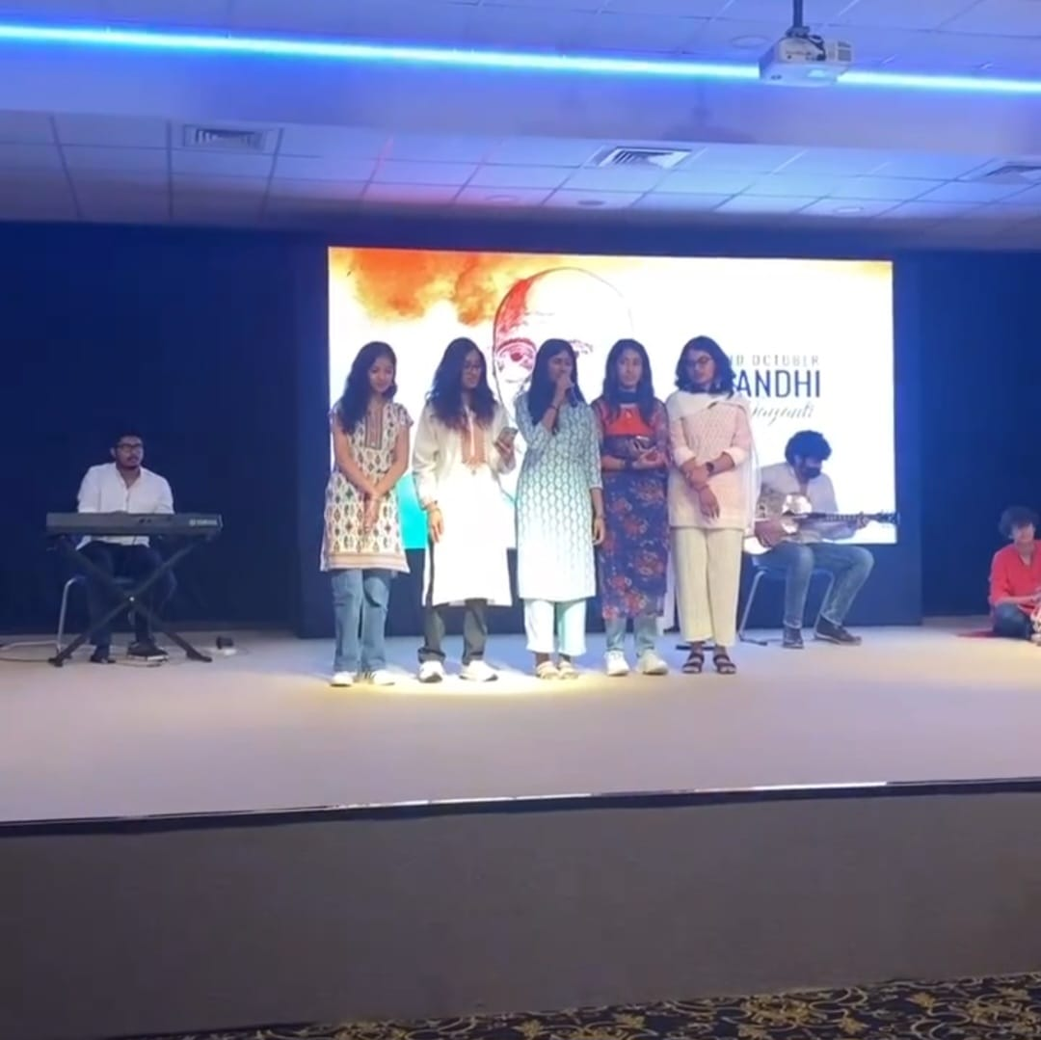

Keiara, Megha, Kanan, Shreya, Anoushka, Karthik, Hrishikesh, Sahil

# **Sparks - October**

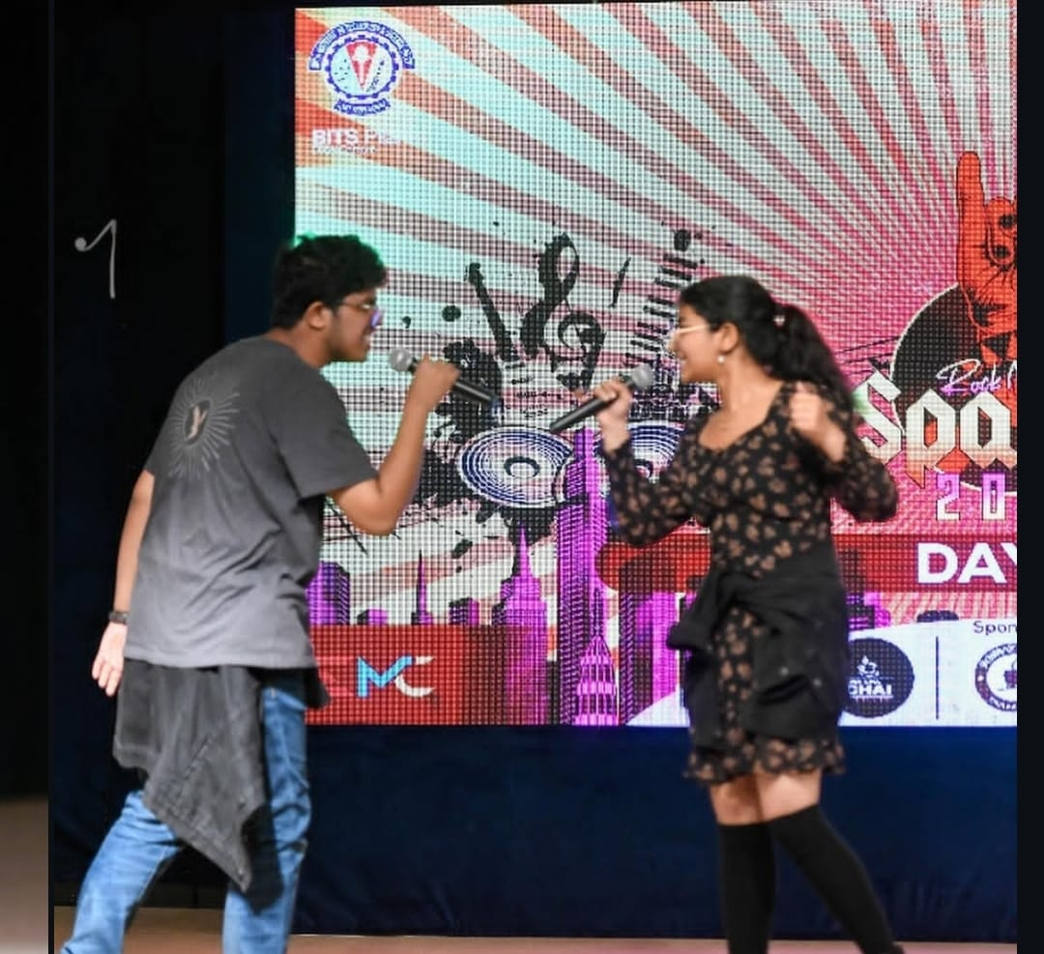 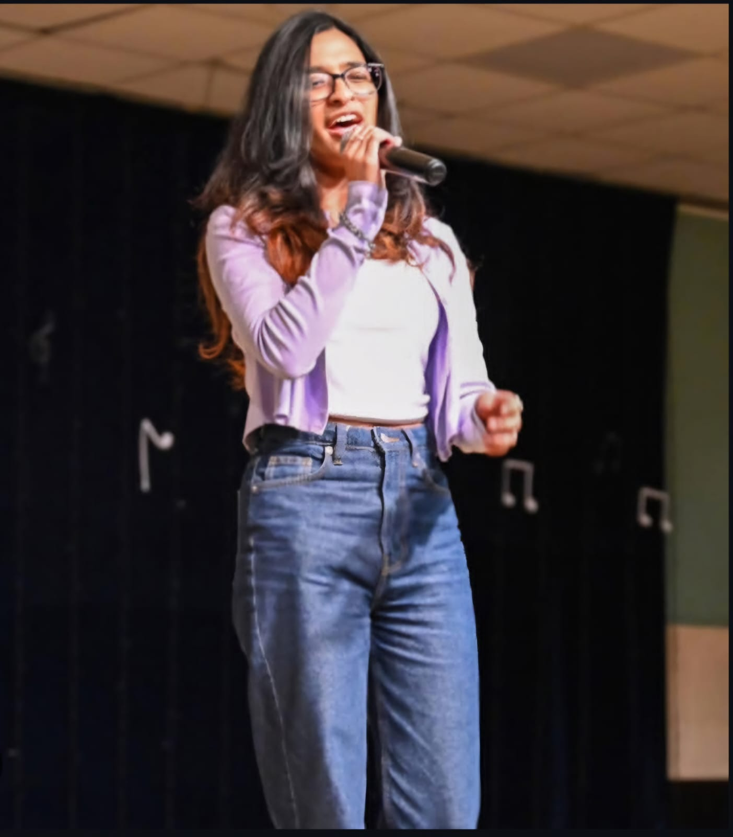

Juan and Neha Keiara Goveas

Sparks is one of the pivotal events of the college year where all students are given the opportunity to display their talents in front of an impartial judge panel, allowing anyone to step up and take a shot at victory. It is the launch pad for Jashn, where participants are then selected for their associated events.

|  |  |  |
| --- | --- | --- |
| Category | First Place | Second Place |
| Western Solo | Sahil Subramaniam | Christina George |
| Eastern Solo | Megha Jayakumar | Sheryl John |
| Western Duet | Juan and Neha | Sahil and Christina |
| Eastern Duet | Bharatwaj and Megha | Mitul and Sheryl |
| Instrumental | Mevin Mathews | Jonathan Sam |

# **World Mental Health Day-October**

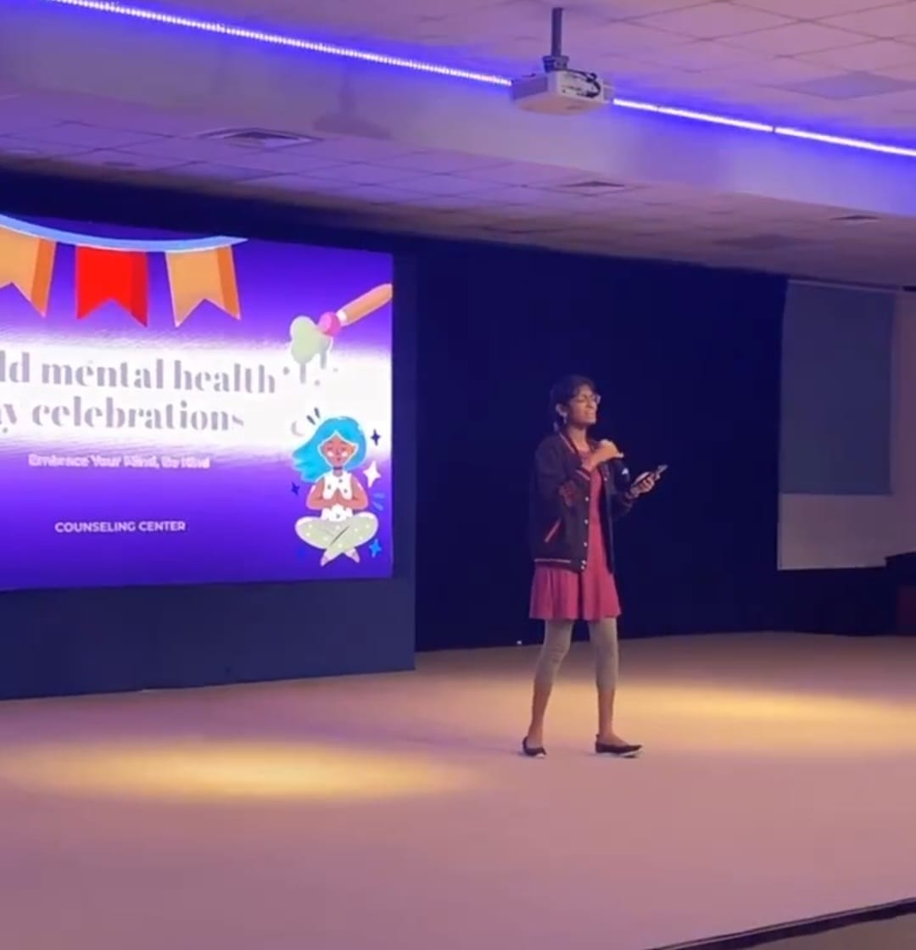 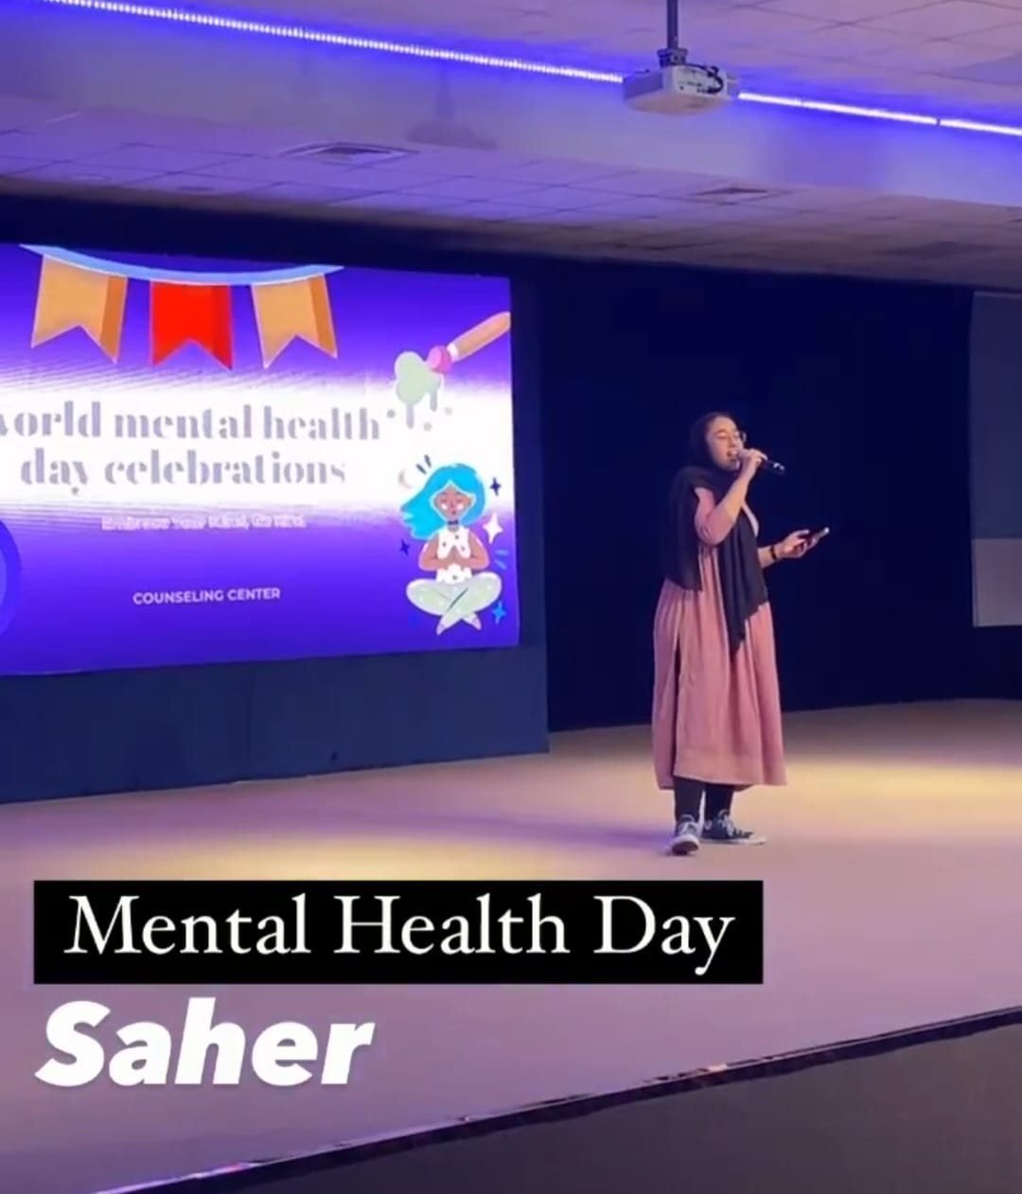

On **Mental Health Day**, the Music Club added a special touch with some beautiful singing performances. The heartfelt melodies filled the air, creating a calming and uplifting vibe that everyone appreciated. It was a reminder of how powerful music can be in helping us relax and feel more connected, making the day even more meaningful for everyone who attended.

# **Ethnic Day-November**

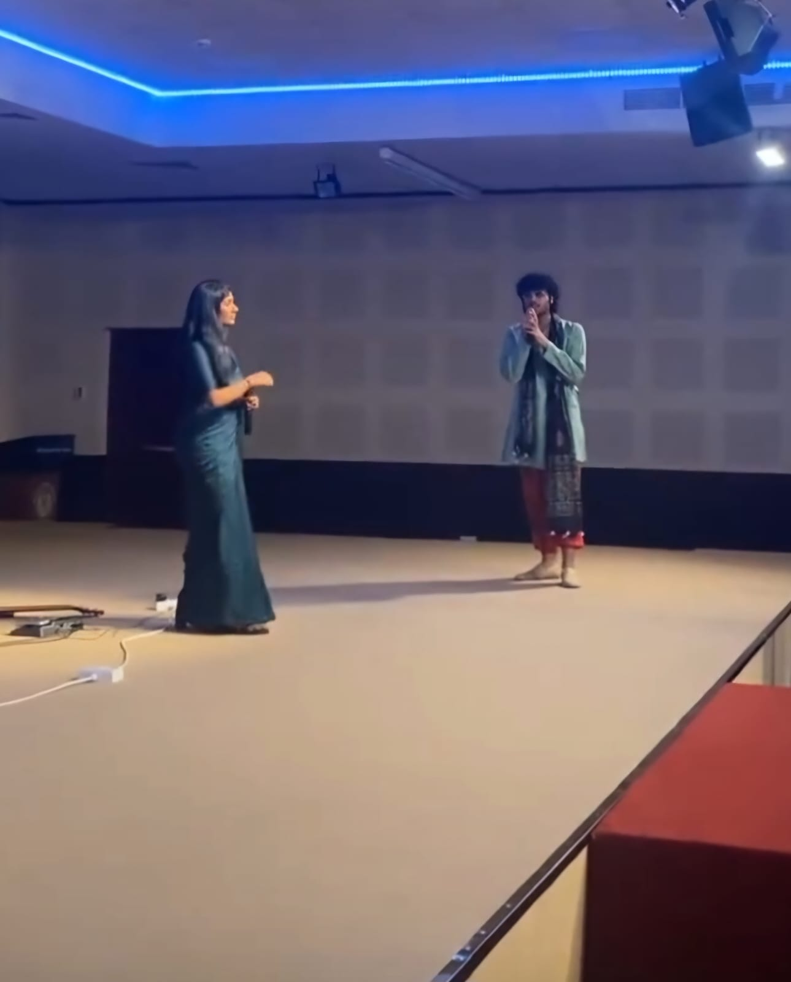 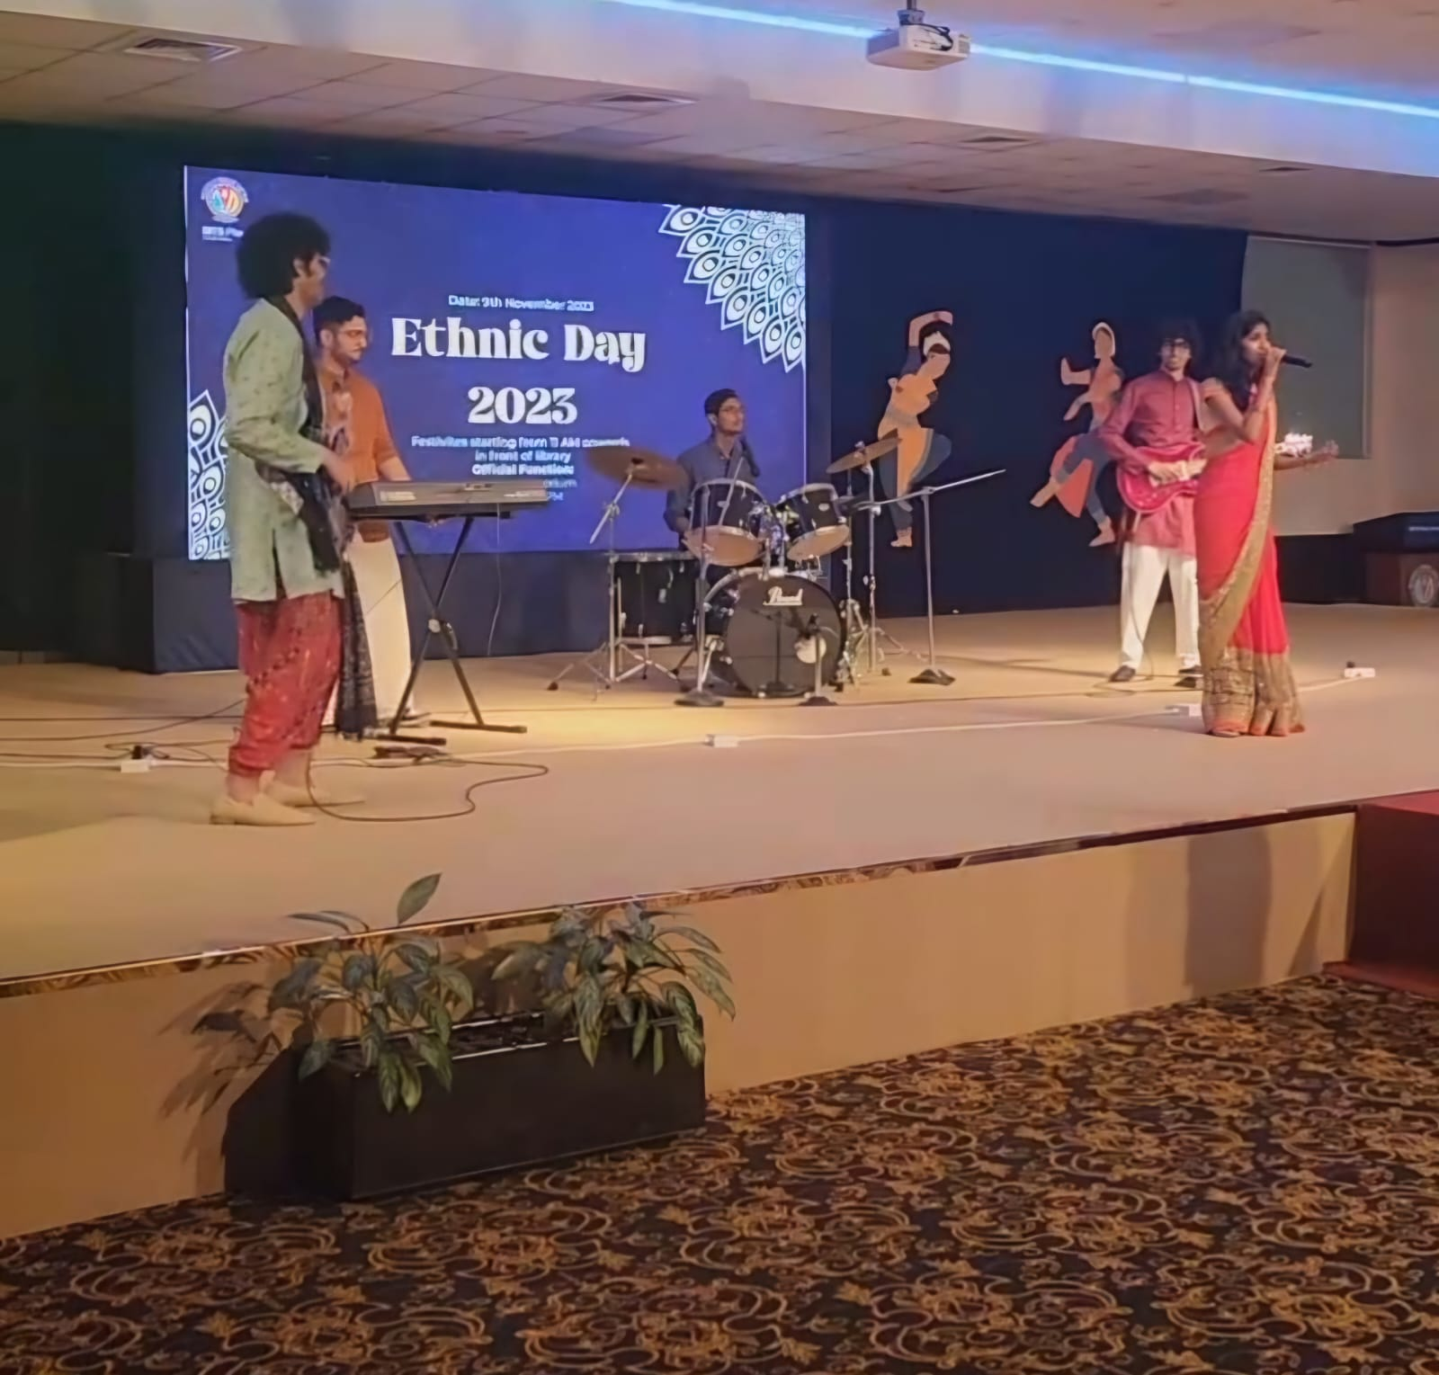

Band Performance ft. Megha Band Performance ft. Sheryl

On **Ethnic Day**, the Music Club showcased vibrant band performances, featuring two talented singers who added a unique flair to the event. One singer captivated the audience with a powerful rendition of a single song, while the other brought their energy and style to another performance. Together, they enriched the band's act, creating a lively and memorable experience that perfectly complemented the cultural celebration.

# **CityWalk-November**

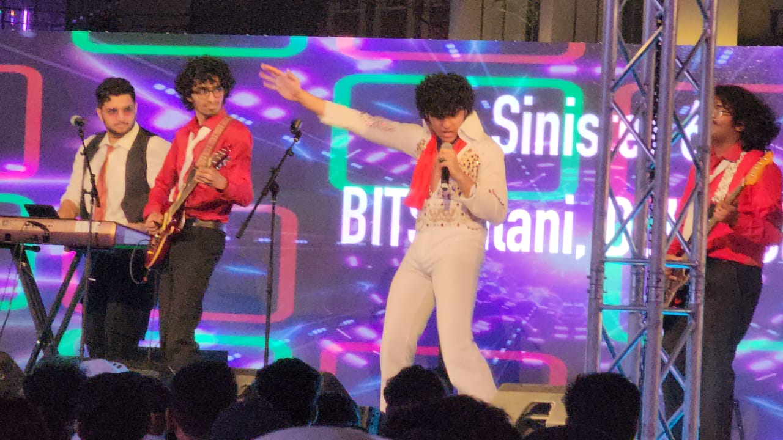 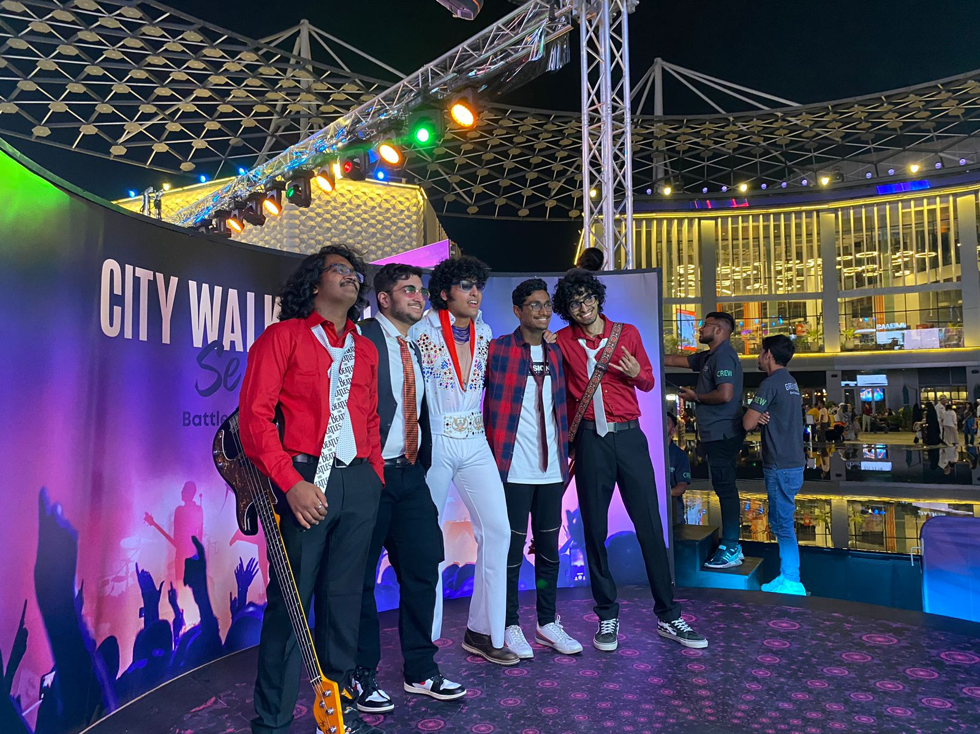

The Music Club participated in an exciting event, **Citywalk Battle of the Bands**, where the official band of BITS Pilani, **Sinister 6ix**, competed against several universities for coveted cash prizes. The performance was a heartfelt tribute to the legendary Elvis Presley, celebrating his timeless contributions to music.

The band delivered an electrifying set of classic rock and roll hits, blending high-energy instrumentals with captivating vocals that had the audience on their feet. The lively performance resonated with the crowd, earning cheers and enthusiastic applause throughout. It was a proud moment for the band to represent the university on such a grand stage while staying true to the spirit of rock and roll.

# **BSF - December**

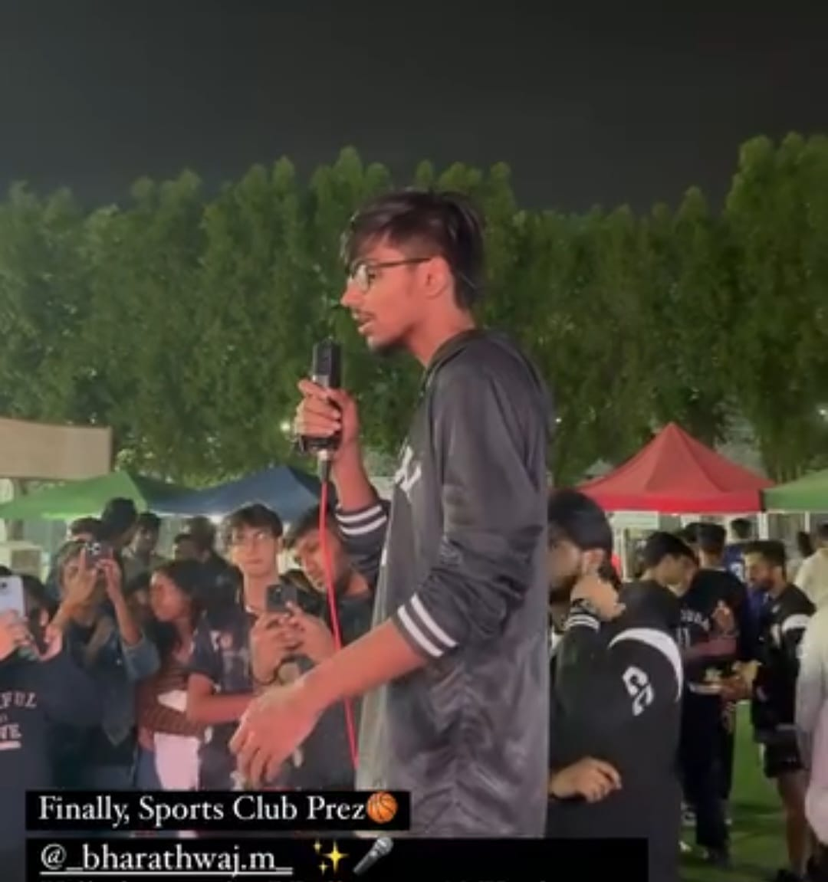 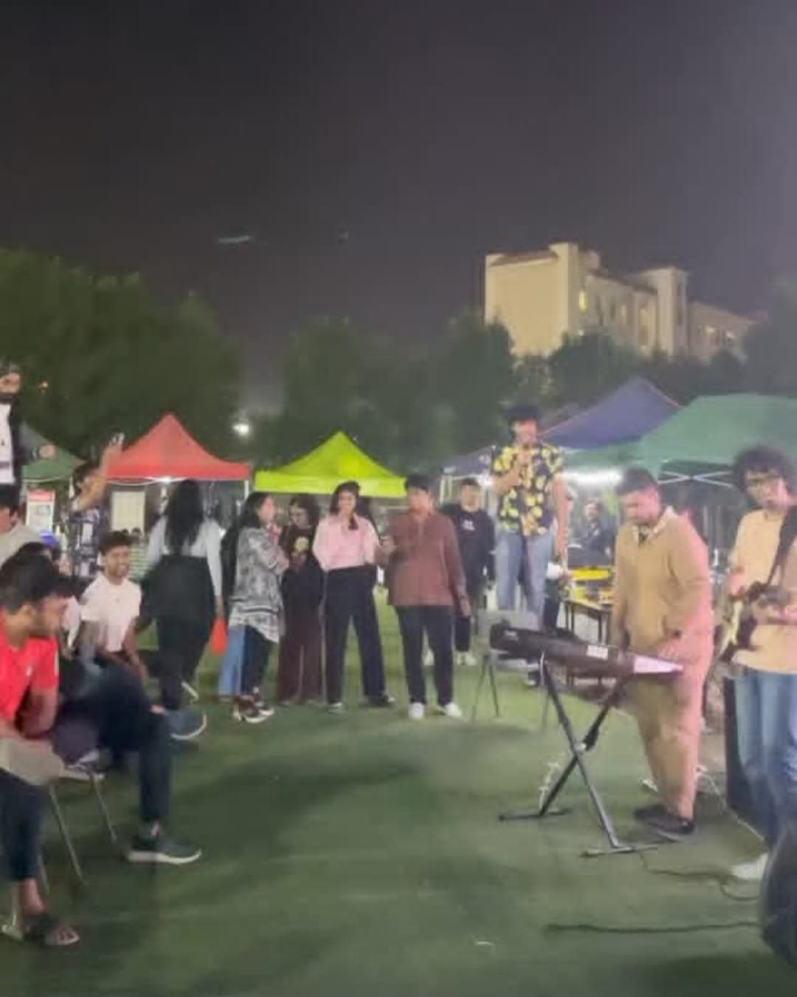

Bharathwaj Band Performance

During the **BITS Sports Festival**, the Music Club added a vibrant musical element to the event with a special band performance. The stage was opened up to everyone, inviting the audience to join in and showcase their singing talents alongside the band. This interactive segment created a lively and inclusive atmosphere, where participants celebrated both music and the competitive spirit of the festival.

As the event drew to a close in the evening, the official band of BITS Pilani took center stage to wrap up the night with a stellar performance. Their energetic set kept the crowd buzzing, ensuring the festival ended on a high note while maintaining the lively sports spirit till the very end.

# **Minute to Win It - January**

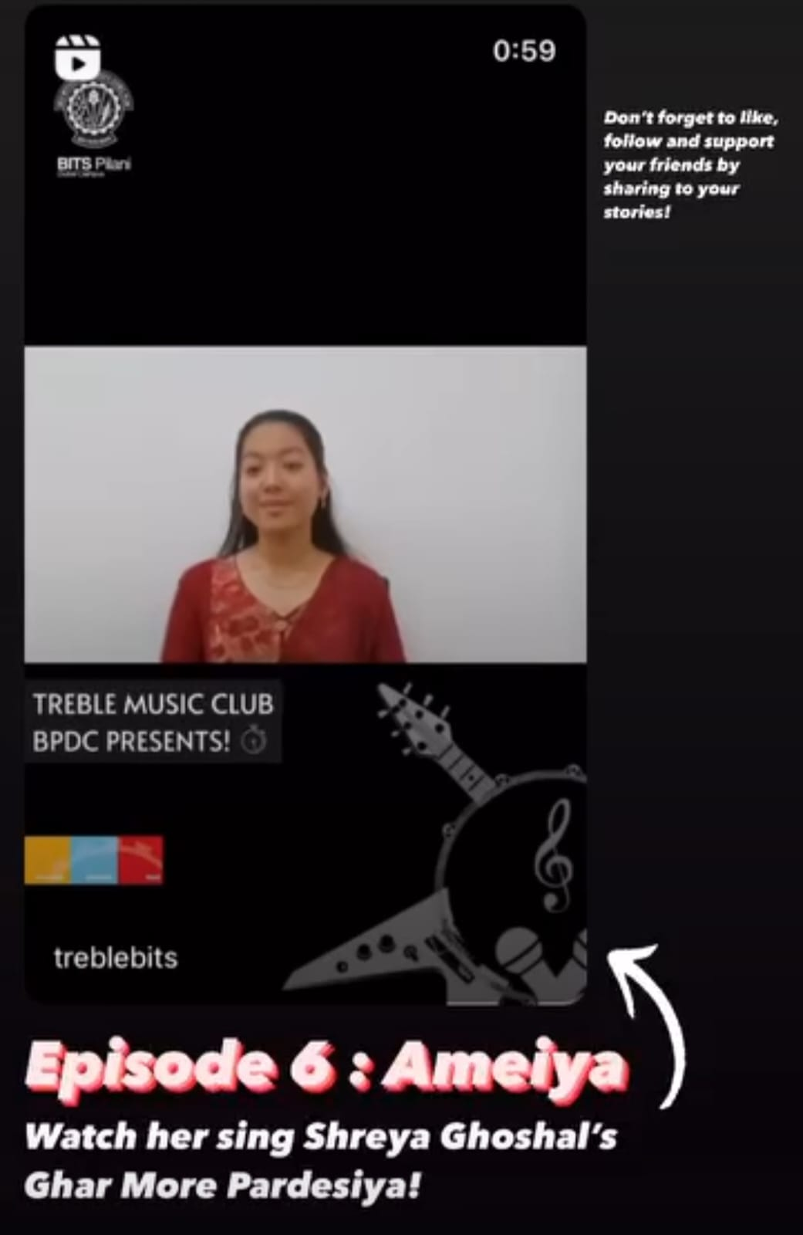 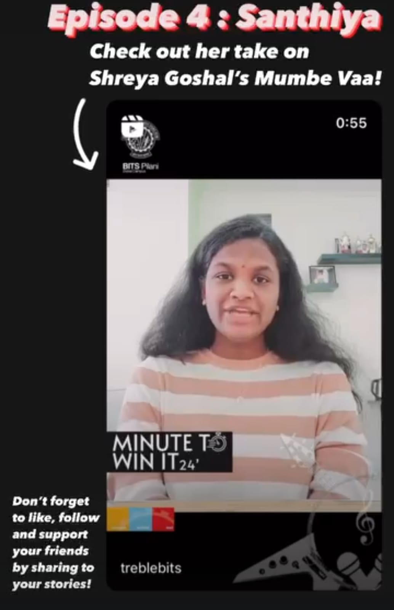

Ameiya Santhiya

During the **winter vacation**, the Music Club organized the highly anticipated online music competition, **Minute to Win It ‘24**. This event provided a platform for participants to showcase their vocal and instrumental talents across different categories. The competition received enthusiastic participation, with each category offering exciting performances. The winners in each category were as follows:

**Eastern Singing**  
1st: Megha Jayakumar  
2nd: Bharathwaj M.  
3rd: Sheryl John

**Western Singing**:  
1st: Christina George  
2nd: Saher Kagadi

**Instrumental**:  
1st: Vania Roy  
2nd: Jonathan Sam  
3rd: Aditya Aggarwal

The competition offered a unique opportunity for participants to express their creativity and musical prowess, while also fostering a sense of community among music enthusiasts. The wide variety of performances made the event even more exciting, and the winners truly demonstrated exceptional talent.

# **Alumni Meet(Raviver)-March**

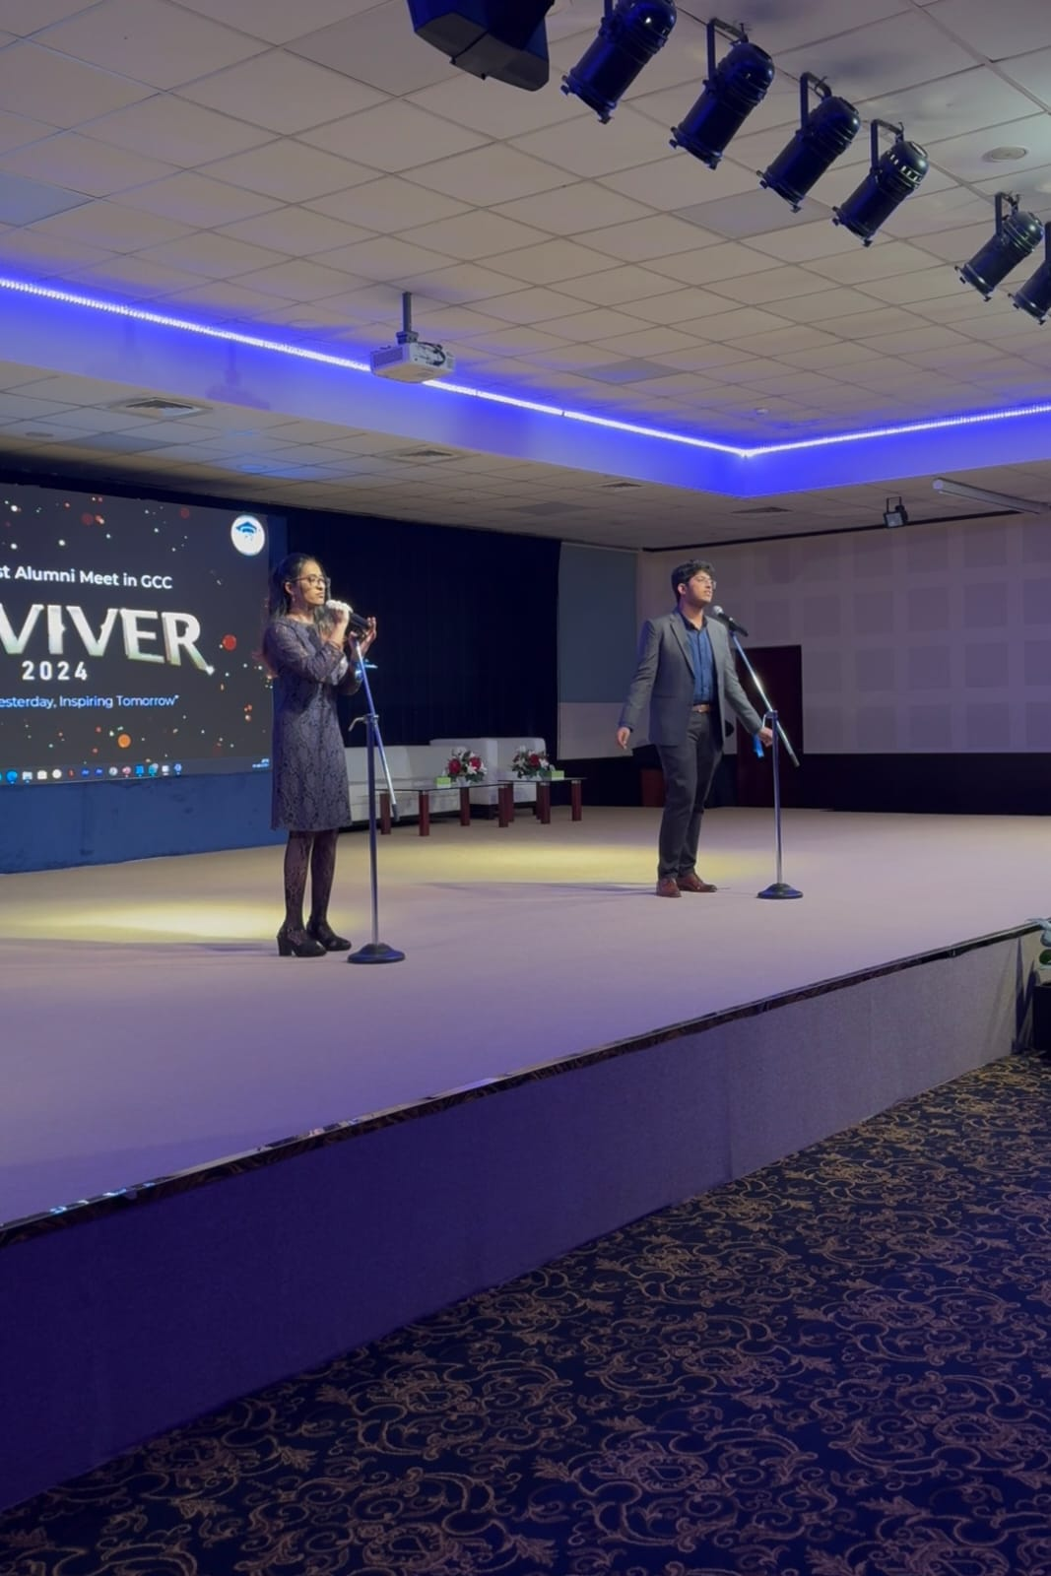

Juan and Keiara

At the **Alumni Meet (Raviver)**, **Juan** and **Keiara** delivered a stunning mashup of "Take Me Home, Country Roads" and the iconic "I'll Be There for You" (Friends intro). Their slow, soulful rendition of "Take Me Home, Country Roads" seamlessly transitioned into the upbeat and familiar theme of "I'll Be There for You." The performance struck a perfect balance between emotion and energy, creating an intimate yet lively atmosphere. Juan's heartfelt vocals and Keiara's expressive delivery resonated deeply with the alumni, evoking both nostalgia and a sense of connection. This unique mashup became one of the event's highlights, beautifully reflecting the spirit of the reunion while showcasing their impressive musical talent.

# **Jashn-April**

Battle of the Bands(BITS) Instrumental(Mevin)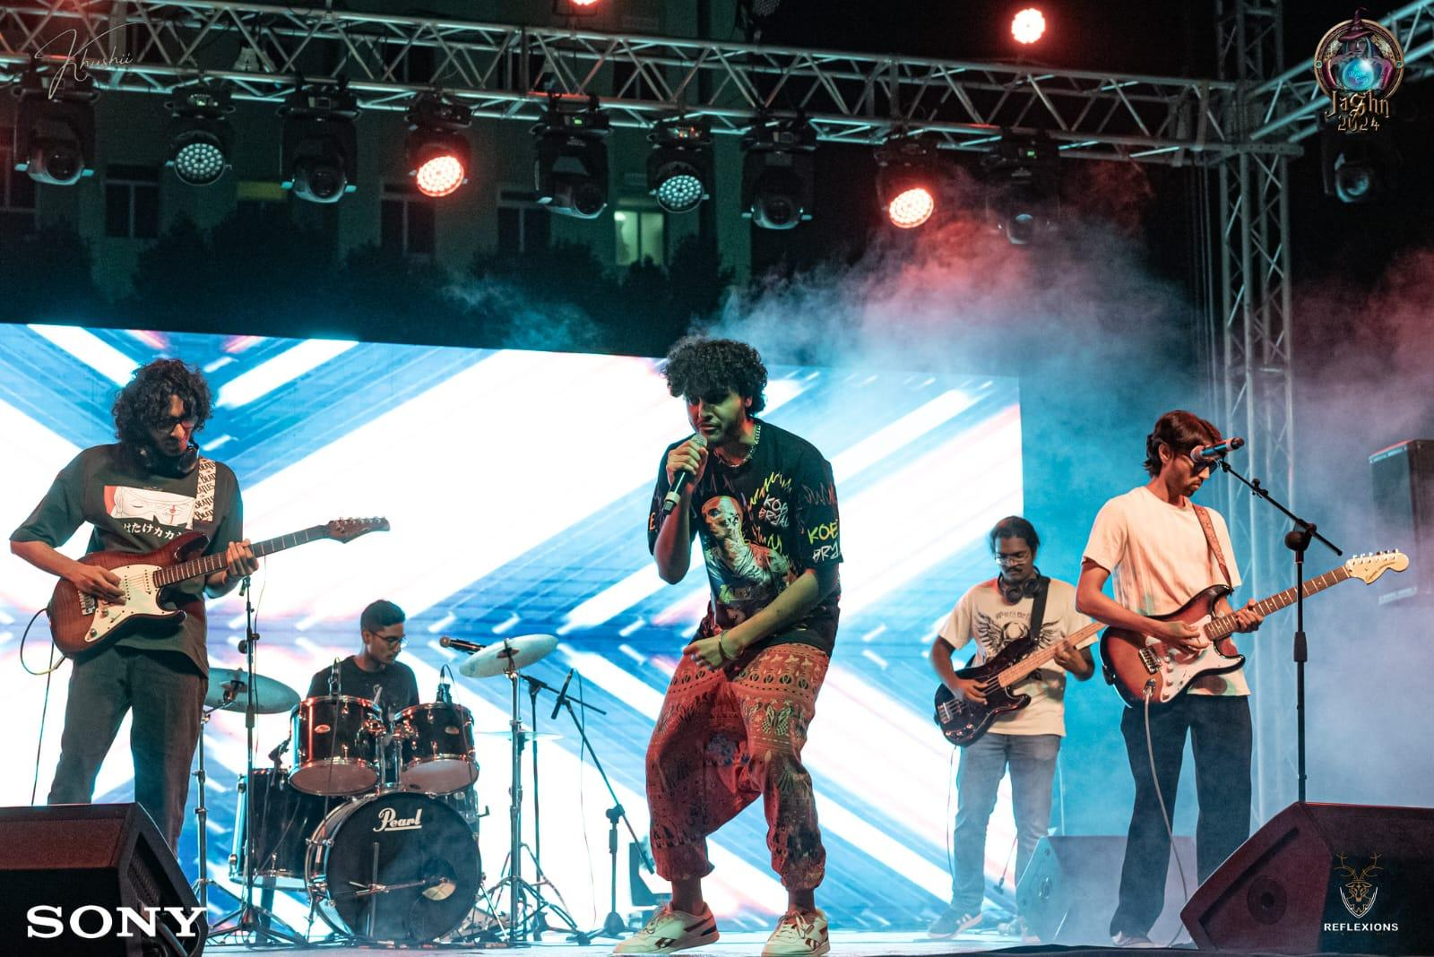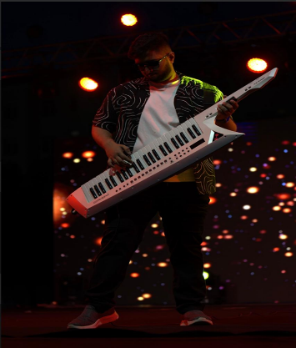

|  |  |  |  |
| --- | --- | --- | --- |
| Day | Event | Position Secured | Participants |
| 1 | Battle of Bands | Competed | Instruments:   1. Anish Ingale (Guitar) 2. Ishan Menezes (Guitar) 3. Ishan Rajesh (Bass) 4. Jonathan Sam (Drums) 5. Mevin Mathews (Keyboard)   Vocalist: Sahil Subramaniam |
| 2 | Eastern Solo | 2nd Place | Megha Jayakumar |
| 3 | Eastern Duet | 2nd Place | Bharathwaj M. and Megha Jayakumar |
| 4 | Western Solo | 2nd Place | Sahil Subramaniam |
| 3 | Western Duet | Competed | Juan James and Neha John |
| 4 | Instrumental | Competed | Mevin Mathews |

# **Spectrum-April**

Spectrum is an inclusive event meant to bring together students of determination and serves as a connection between them and their traditional education counterparts and peers. The annual event hosted by SEC-MAD Club invites more than 150 students of determination along with their teachers to have fun activities in this organized event. The theme was ‘Arabian Nights’ to engage the children in something that interests them. There were two duets from the students of BITS, Aileen and Saher sang ‘A whole new world’ accompanied by Rohan on the guitar, after that we had a few performances from the schools that visited us.. It was indeed very wholesome and adorable! We closed the event off with a duet by Siddhi and Sheryl who sang ‘Love is an open door’ and everyone enjoyed it.

